1. **Adventure work Database (SQL Server) to Fabric Lakehouse**

LookupActivity :-

**Query :-**

select B.Name 'SchemaName', A.name 'TableName' from sys.tables A

inner join sys.schemas B ON A.schema_id=B.schema_id

where B.name='SalesLT'

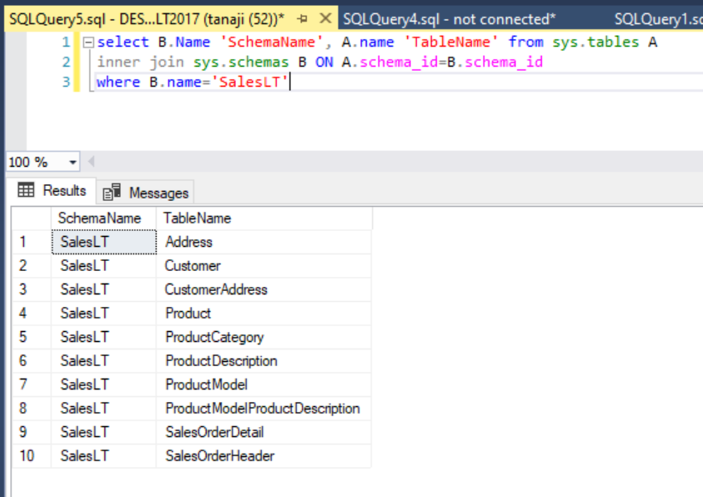

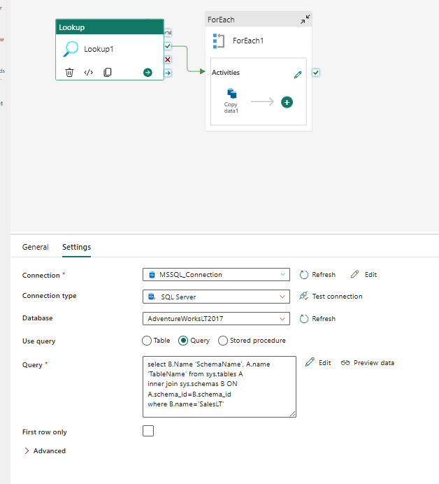

**Foreach Activity:-**

@activity('Lookup1').output.value

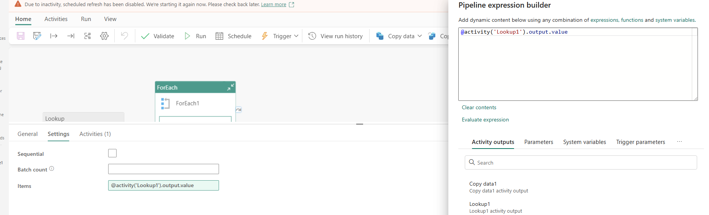

**Copy activity:- ( Source and Destination connection)**

First you need to configure on premise Gateways for SQL connection and establish SQL server Conection

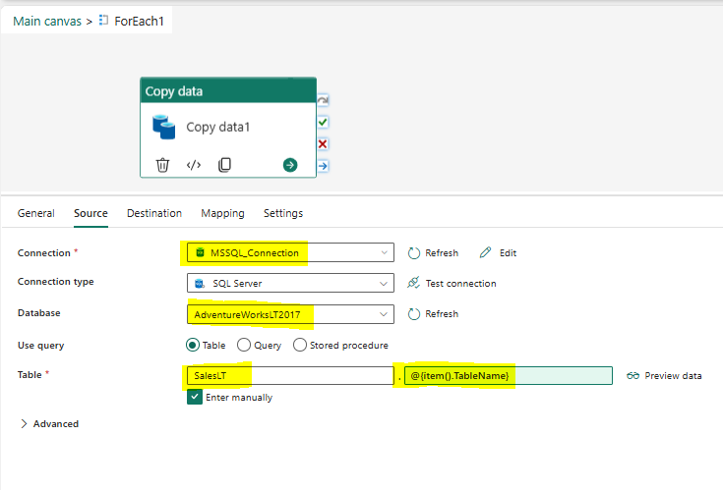

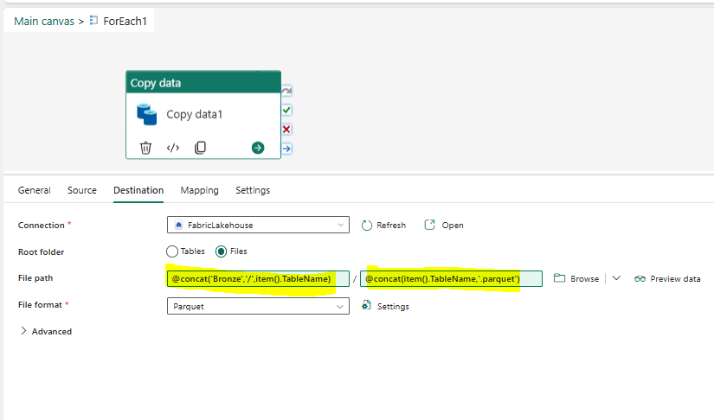

**File path:-** @concat('Bronze','/',item().TableName)

**File Name:-** @concat(item().TableName,'.parquet')

1. **MY SQL to Fabric Lakehouse**

Configure Gateway and establish connection for MY SQL server

**Source**

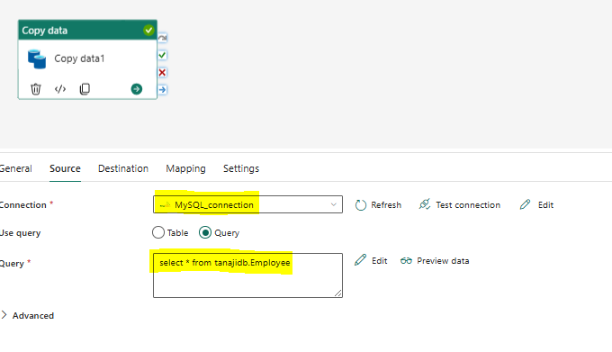

**Destination**

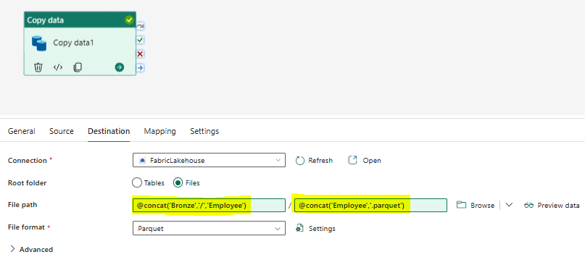

**File Path: -** @concat('Bronze','/','Employee')

**File Name: -** @concat('Employee','.parquet'

If you are getting error for connecting MY SQL server then run below power shell script

**Powershell script**

[System.Data.Common.DbProviderFactories]::GetFactoryClasses()|ogv